**Enjoying good company**

**Reading:** Acts 2:42-47

The believers studied what the apostles taught. They shared their lives together. They ate and prayed together. Everyone was amazed at what God was doing. They were amazed when the apostles performed many wonders and signs. All the believers were together. They shared everything they had. They sold property and other things they owned. They gave to everyone who needed something. Every day they met together in the temple courtyard. They ate meals together in their homes. Their hearts were glad and sincere. They praised God. They were respected by all the people. Every day the Lord added to their group those who were being saved.

**Thought about the reading**

At Pentecost, God poured out his Holy Spirit on Jesus’ friends and they started praising God in different languages. People around them heard this and wondered what was going on. Peter stood up and told them the good news, that Jesus had died on the cross, but now was alive! Three thousand people decided to be baptised as Christians! This was the beginning of God’s Church.

You may go to church on a Sunday, in a special church building. But the building is not really the church. It is the people inside who are the church.

God’s Church includes everyone who follows him, whatever building they meet in. It is this Church that God is using to change the world.

If you are following Jesus, then you too are part of God’s Church. The reading today tells us what those first Christians did. They listened to the teaching of the apostles, who were the first followers of Jesus. They shared everything they had with each other. They met together and ate and prayed together. They probably had Holy Communion together. They also worshipped together, singing praise to God.

If we are following Jesus, then it is important to try and meet with other Christians, to worship and pray and take Holy Communion together. Like the first Christians, we can listen to teaching about how to follow Jesus and we can help each other. This is how Jesus wants us to live.

**Prayer**

Dear Jesus, thank you for making each of us part of your Church. Please help us to meet together and to learn to love each other and worship you, just as the first Christians did. Amen

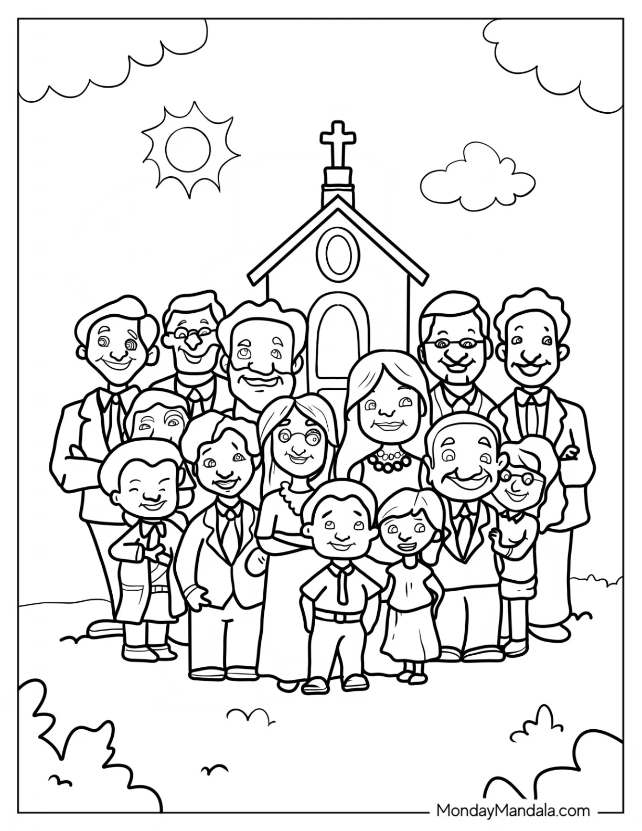

**Cambridge Causeway**

Summer 2025

Bible Study notes

**How Jesus wants me to live**

**7. Enjoying good company**

By Chrissy Cole